forward thinking company
individual coaching session set up form
name
email address
contact number
DOB
career

To help me get to know you before our sessions, please answer the below questions:
What do you value most about yourself?
What things are you passionate about in the world?
What do you consider your greatest achievements and what are you most proud of?
What values do you admire most in other people?
How would your family & friends describe you?
What have been your biggest challenges so far in life?

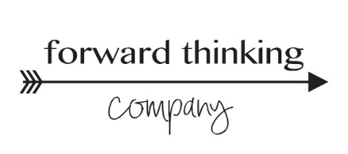
What are your biggest fears/limiting beliefs?
What is currently missing or limited in your life that you would like more of?
If time, money & other resources were not a constraint, what would you do today?
Where are you held back, uninspired and lacking drive in your life?
In order of priority, what areas would you like to focus on during your sessions?
Any additional information that will help support your coaching sessions?

Please email the completed form to trevor@forwardthinkingcompany.com. Once received you can expect an email within 48hrs to set up a 15min connection call. During this call we will go through the form, get clear on the outcomes you are looking for and confirm your coaching call times.

